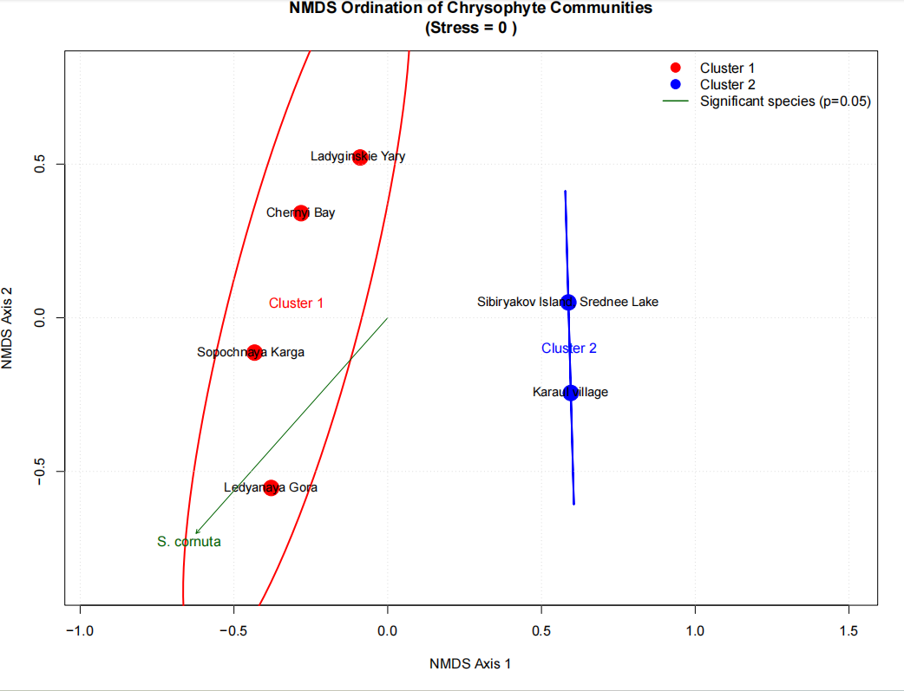
Figure 1: NMDS 2 Clusters
From the above figure we can see that:

Cluster 1 (red): Ladyginskie Yary, Chernyi Bay, Sopochnaya Karga, and Ledyanaya Gora.

Cluster 2 (blue): Sibiryakov Island–Srednee Lake and Kara Village.

The clear separation along NMDS Axis 1 indicates that the chrysophyte communities in Cluster 1 differ considerably from those in Cluster 2. The black vector representing Synura cornuta (S. cornuta) suggests that this species significantly contributes to the differences among the sites. And finally a stress value of 0 indicates an excellent ordination fit, meaning the plot accurately represents the relationships among samples.

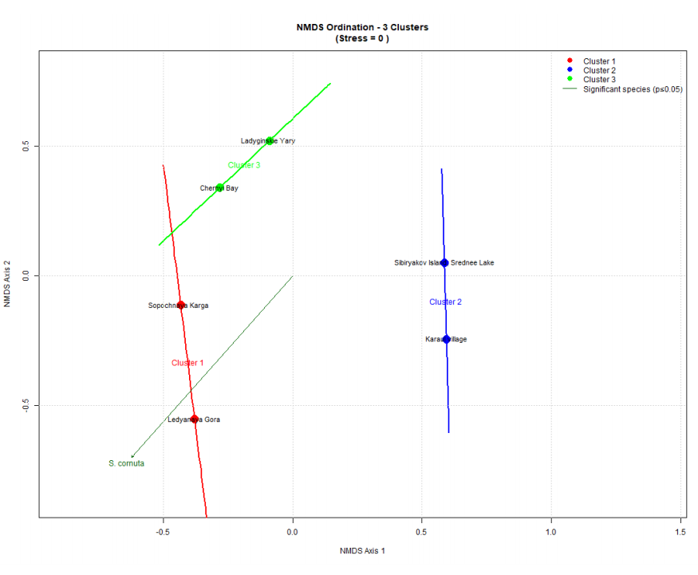
Figure 2: NMDS 3 Clusters
From the above figure we can see that:

Cluster 1 (red): Sopochnaya Karga and Ledyanaya Gora.

Cluster 2 (blue): Sibiryakov Island–Srednee Lake and Kara Village.

Cluster 3 (green): Ladyginskie Yary and Chernyi Bay.

This arrangement suggests that Ladyginskie Yary and Chernyi Bay have a community composition distinct enough to form their own cluster rather than being grouped with the other red sites. The significant species vector (S. cornuta) still points toward the lower-left area, indicating its association with sites in that direction. The stress value of 0 again shows that the ordination provides a very reliable representation of the community similarities.

